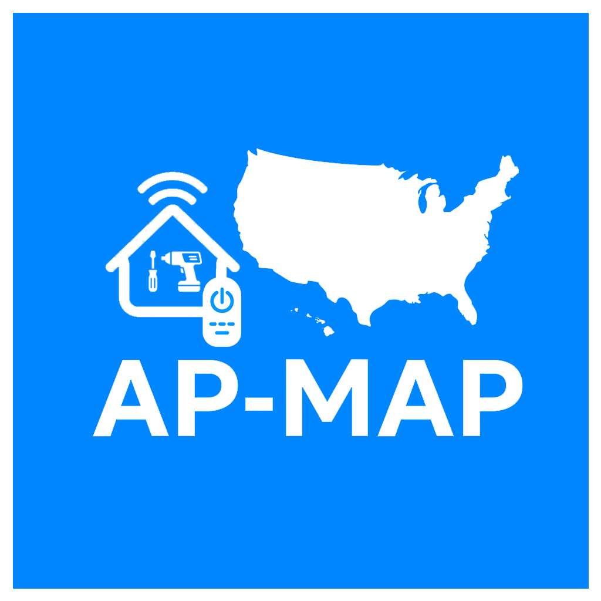

AP-MAP Heating & Cooling
Professional HVAC Services & Pricing Guide for Chicago & North Shore Suburbs.
Residential • Commercial • Heating • Cooling • Hydronic Systems

AC / Cooling Services
Service | Description | Price
AC Diagnostic | Full air conditioning inspection and diagnostics | $89 – $149
AC Repair | Cooling repair, airflow, electrical and thermostat issues | $149 – $650+
AC Tune-Up | Seasonal AC maintenance and cleaning | $89 – $199
Refrigerant Recharge | Freon leak check and recharge | $199 – $650+
Capacitor Replacement | Replace failed AC capacitor | $180 – $450
Condenser Repair | Outdoor condenser repair or replacement | $350 – $2,500
Evaporator Coil Replacement | Replace indoor evaporator coil | $1,200 – $2,800
AC Installation | New central AC installation | $3,500 – $8,500
AC Replacement | Replace old AC system | $2,800 – $6,500
Mini Split Installation | Ductless mini split setup | $2,000 – $7,000
Mini Split Repair | Repair ductless systems | $149 – $850
Thermostat Installation | Smart or standard thermostat setup | $180 – $450

Heating / Furnace Services
Service | Description | Price
Furnace Diagnostic | Heating system inspection | $89 – $149
Furnace Repair | Repair heating issues and breakdowns | $149 – $750+
Furnace Tune-Up | Seasonal furnace maintenance | $99 – $229
Furnace Installation | Install new furnace system | $3,500 – $9,000
Furnace Replacement | Replace old furnace | $3,000 – $7,500
Blower Motor Replacement | Replace furnace blower motor | $450 – $1,200
Ignitor Replacement | Replace furnace ignitor | $180 – $450
Flame Sensor Cleaning | Furnace flame sensor cleaning | $89 – $180

HVAC System Services
Service | Description | Price
HVAC Inspection | Complete HVAC system evaluation | $149 – $299
HVAC Maintenance | Full seasonal HVAC maintenance | $149 – $399
Emergency HVAC Service | Same-day emergency repair | $249 – $950+
Airflow Balancing | Improve airflow and comfort | $250 – $850
Ductwork Repair | Air duct repair and sealing | $350 – $2,500
Ventilation Service | Ventilation inspection and repair | $180 – $1,500
Indoor Air Quality Service | Air purification and filtration | $250 – $2,000
Smart HVAC Controls | Smart home HVAC integration | $250 – $1,200

Water Heater Services
Service | Description | Price
Water Heater Repair | Tank and tankless repair | $149 – $850
Water Heater Installation | Install water heater systems | $1,200 – $4,500
Tankless Water Heater Service | Tankless diagnostics and repair | $199 – $950
Hydronic Heating Repair | Boiler and hydronic heating repair | $250 – $2,500

Commercial HVAC Services
Service | Description | Price
Rooftop Unit Repair | Commercial RTU repair | $350 – $3,500
Commercial HVAC Maintenance | Preventive commercial maintenance | $350 – $2,500
Commercial AC Installation | Commercial cooling installation | $5,000 – $25,000+
Commercial Furnace Service | Heating repair for businesses | $350 – $4,500

Premium Hydronic Radiant Floor Heating
Service | Description | Price
Radiant Floor Heating Installation | Premium heated floor system installation | $6,000 – $25,000+
Heated Floor Repair | Diagnostics and repair of radiant floor systems | $250 – $2,500
Boiler Integration | Hydronic floor heating boiler integration | $1,500 – $6,500
Radiant Floor Maintenance | Seasonal maintenance and inspection | $180 – $650
Smart Heated Floor Controls | Smart zoning and thermostat setup | $350 – $2,000
PEX Tubing Repair | Repair or replacement of hydronic tubing | $450 – $4,500
Luxury Bathroom Heated Floors | Premium radiant bathroom floor systems | $1,500 – $6,000
Whole-Home Radiant Heating | Complete luxury heated floor system | $12,000 – $45,000+

Contact AP-MAP
Phone: +1 (727) 922-0013
Website: https://ap-map.com
Email: hello@ap-map.com

